# Quick Start Guide for Librarians

Login to the Library Management System using the credentials provided by the University

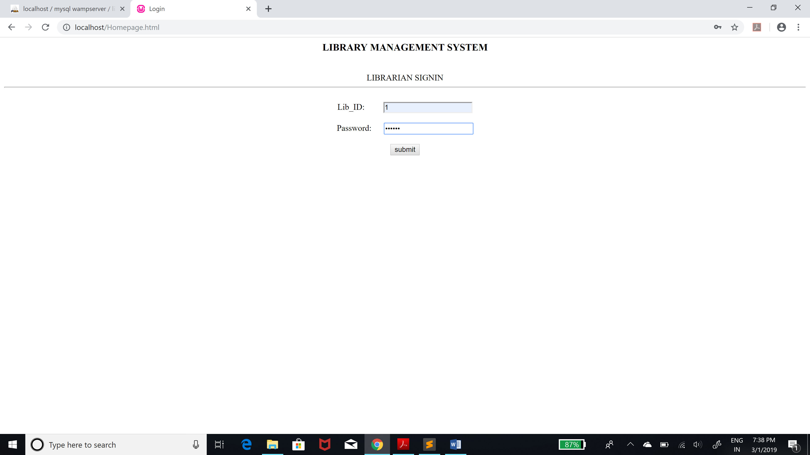

On the Welcome page you will be able to Check-out, Check-in, Search for Books, Pay Fines, Display All Fines and Register new students. 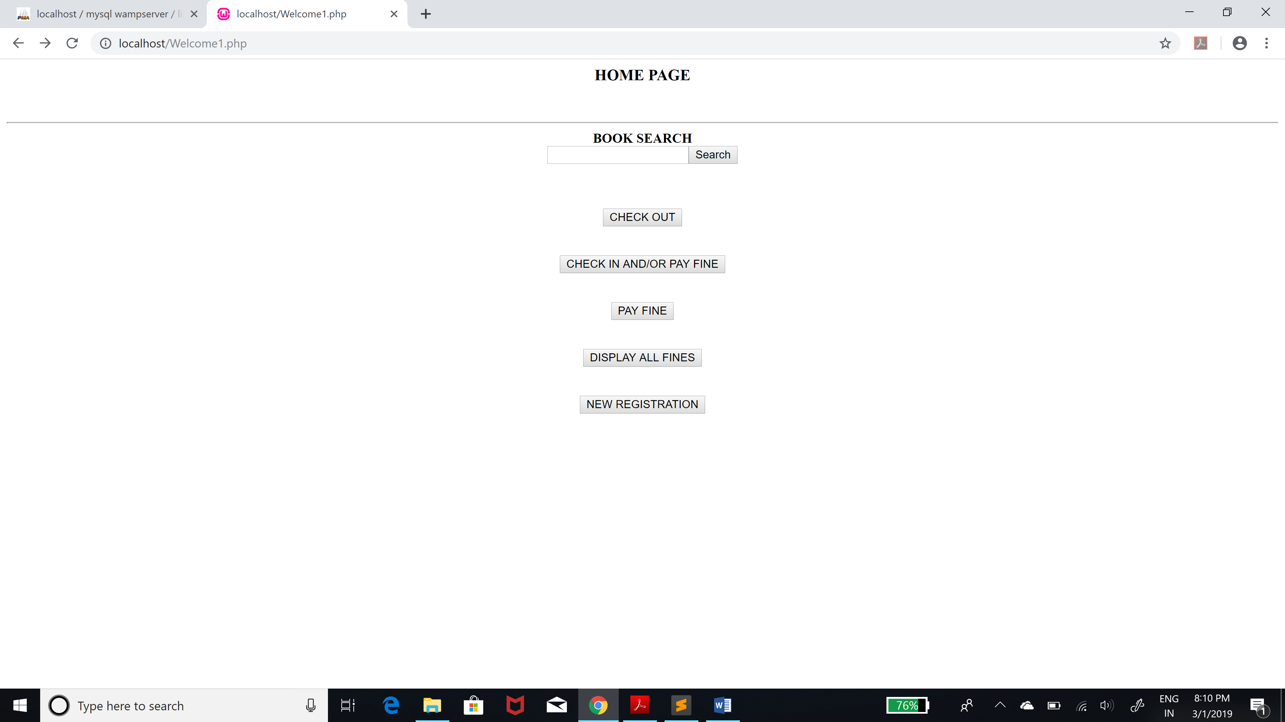

You can search for any book using ISBN, Author Name or Title and also check it’s availability.

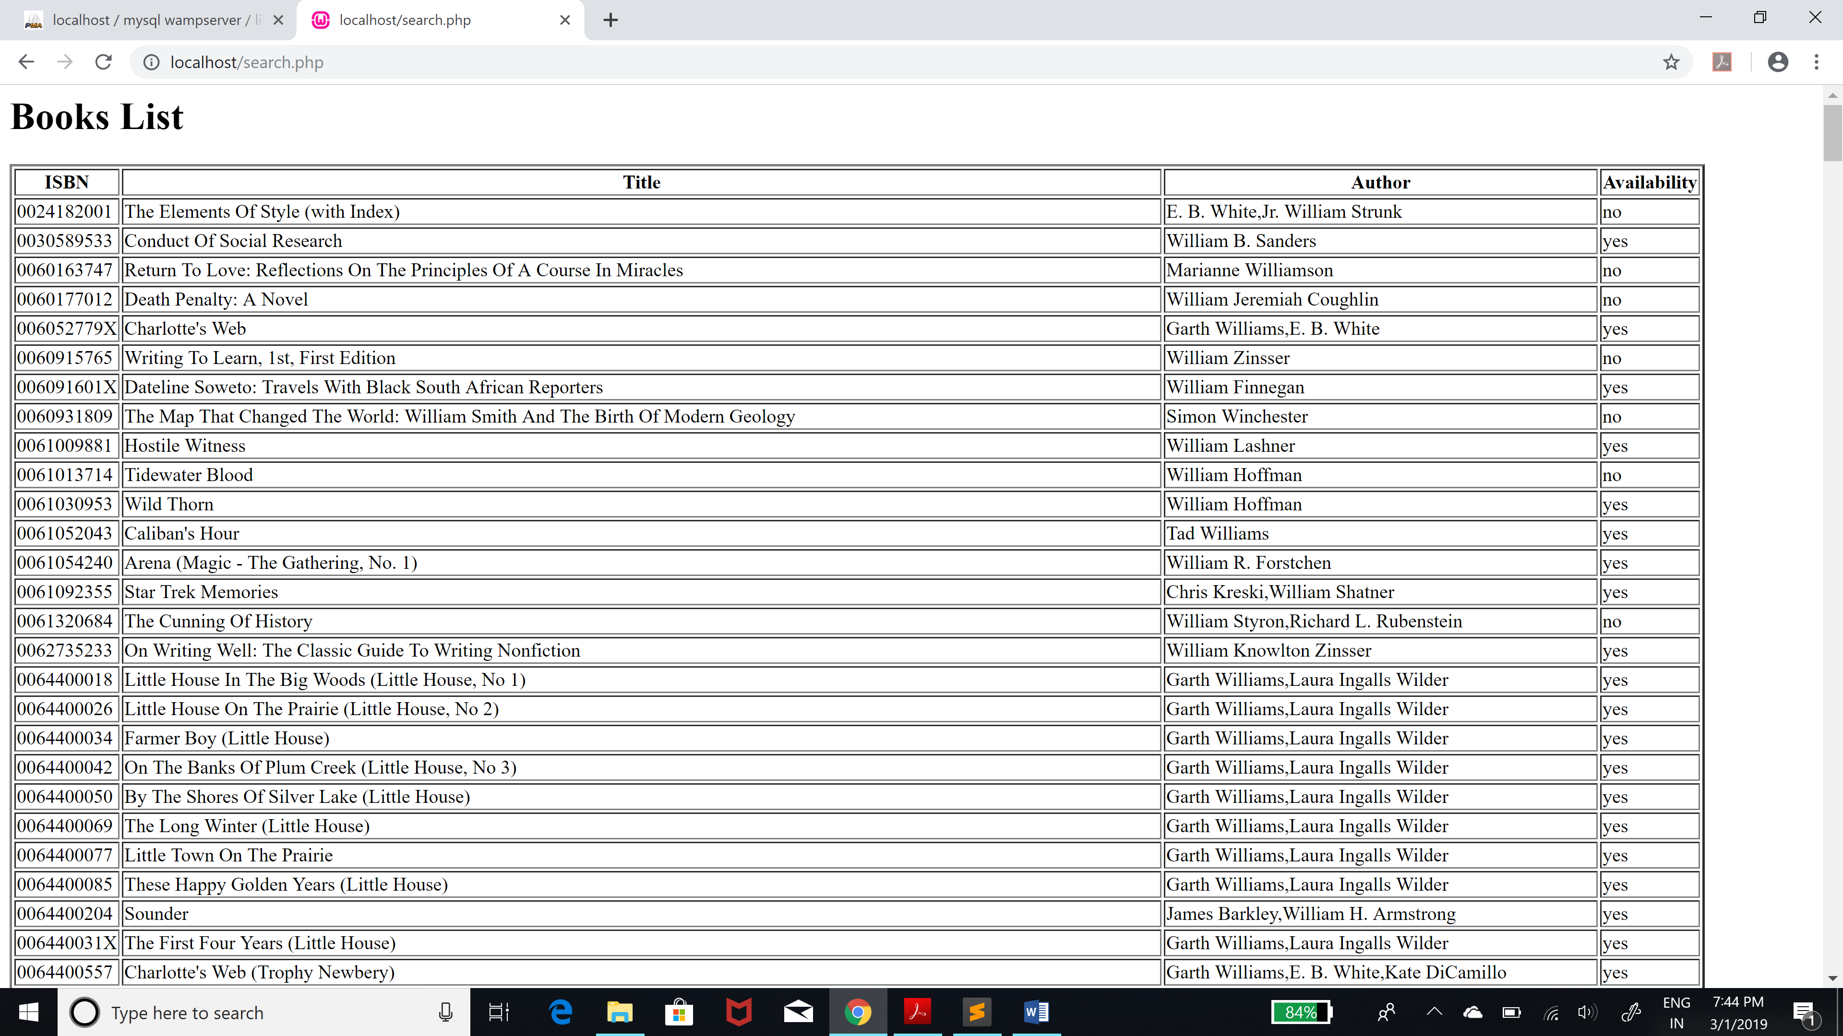

You can checkout books for a student using the ISBN of the book and the student’s card id. However a student is not allowed to take more than 3 books at a time.

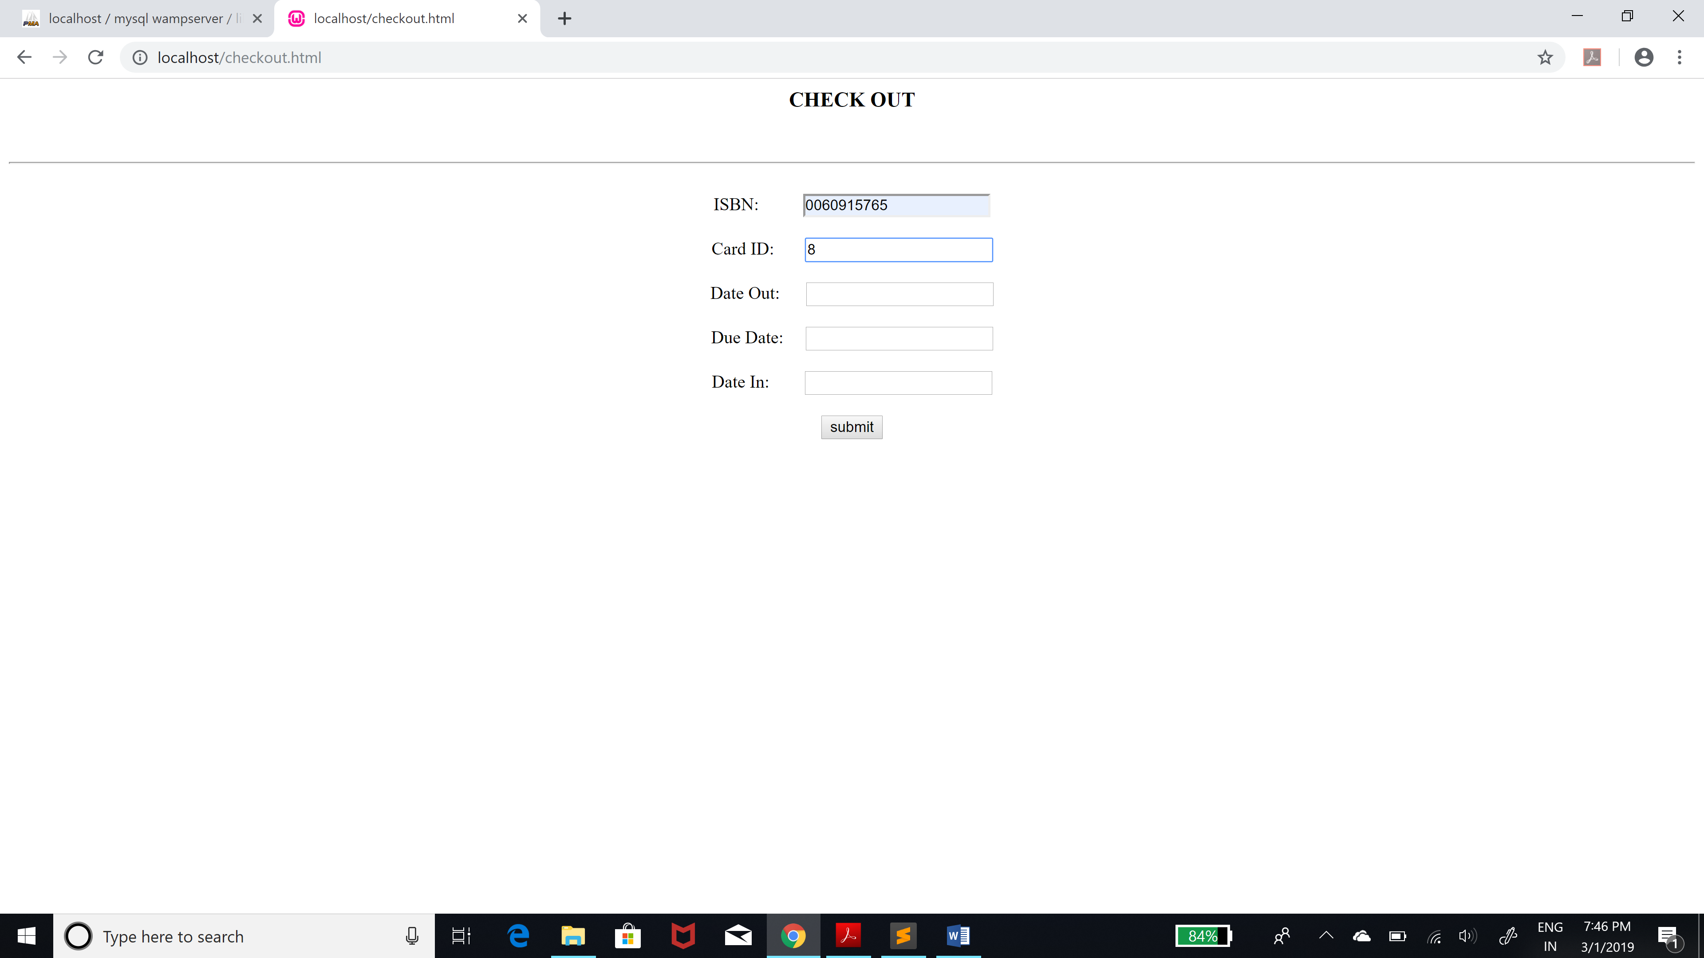

You can check-in a book using ISBN and card id. If that book has no fines check-in will be successful.

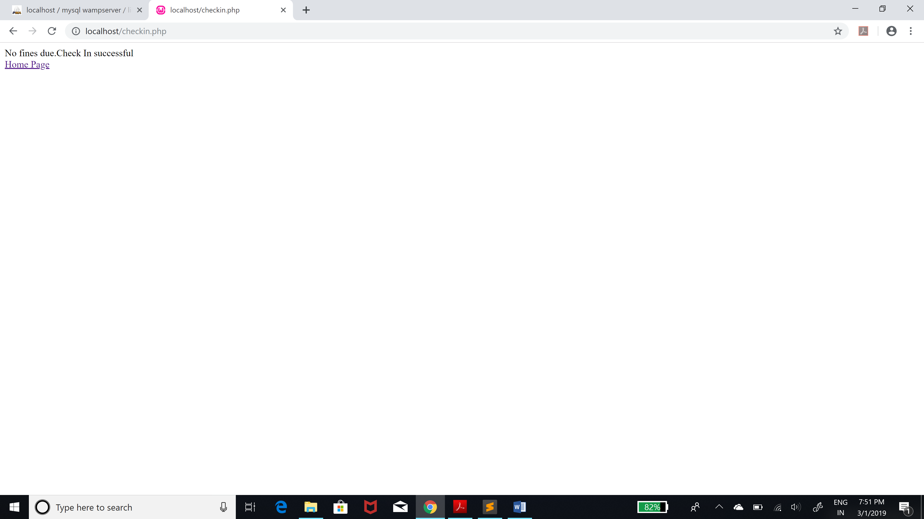

However if there is a fine The fine amount and the loan id will be shown. The student can pay then and there or can pay later using load id receipt that will be generated.

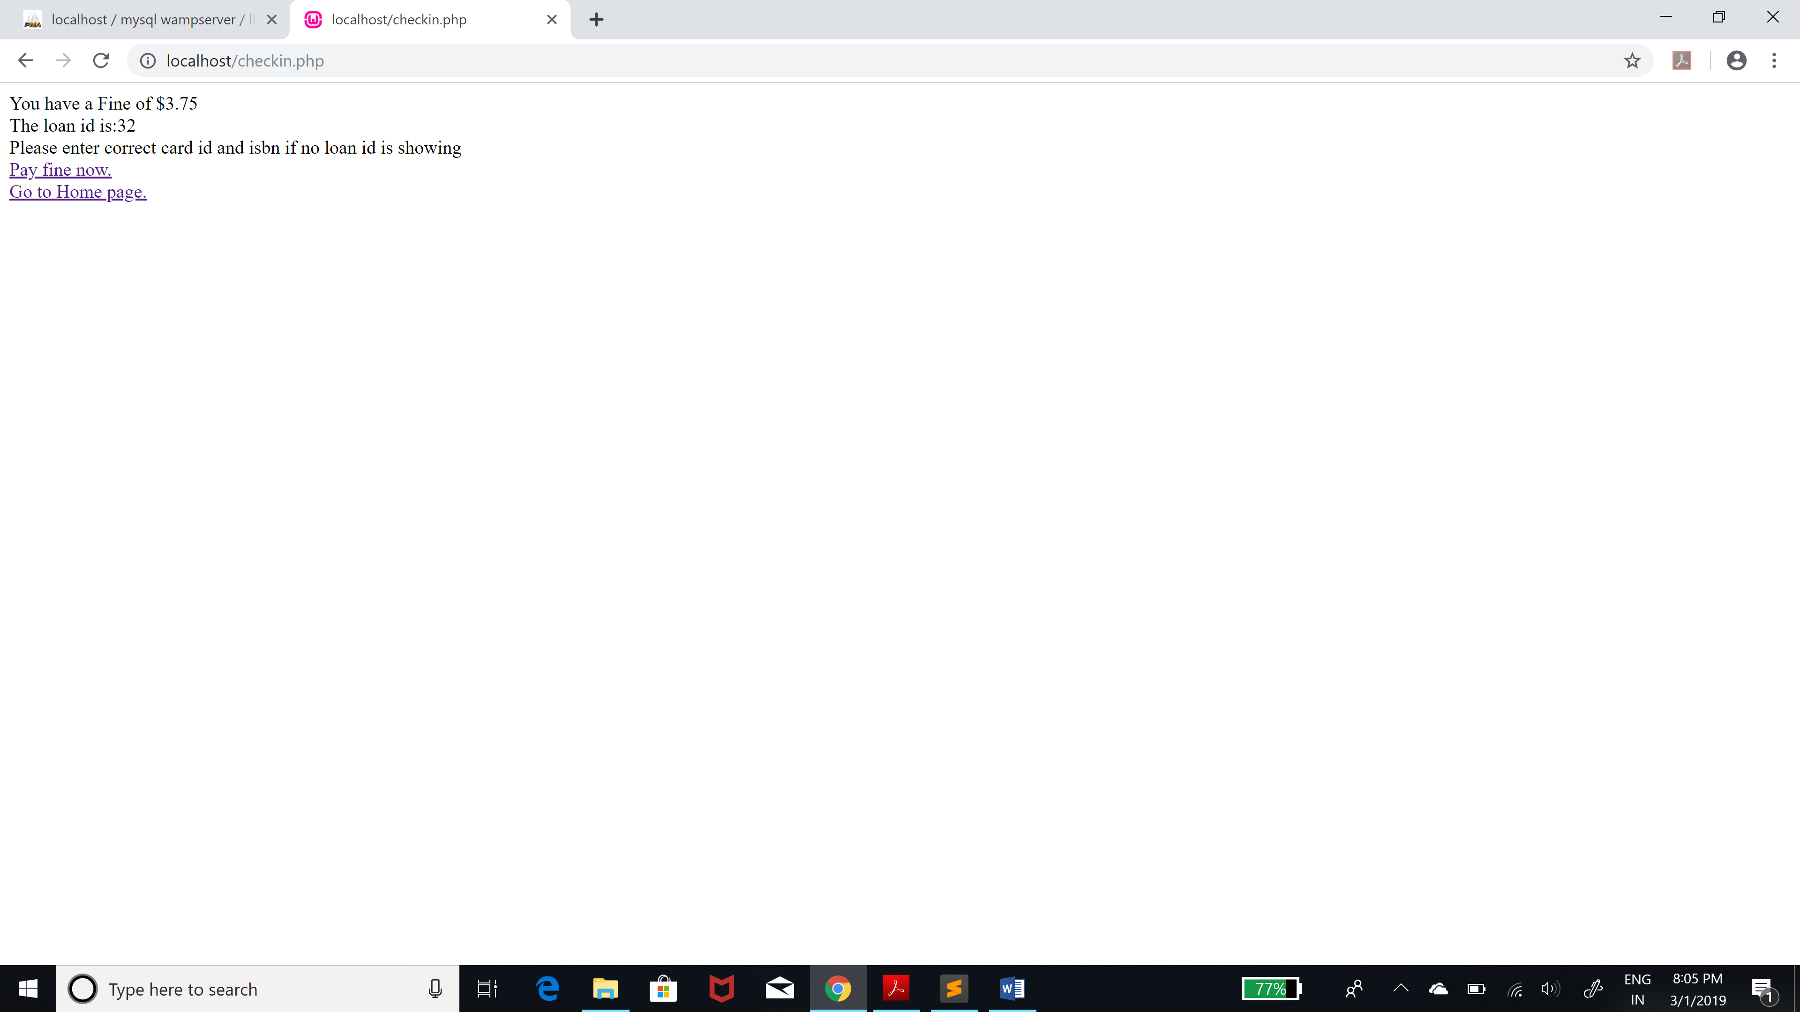

If a student pays fine later he has to bring a receipt with loan id.

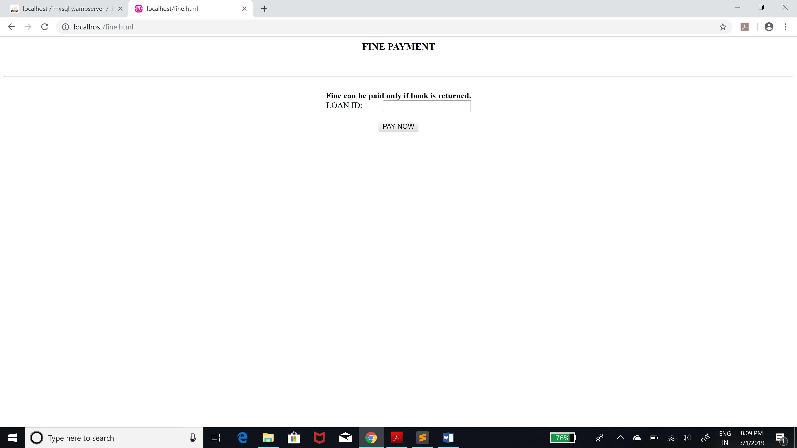

You can check total fines of all students by clicking the Check All Fines button.

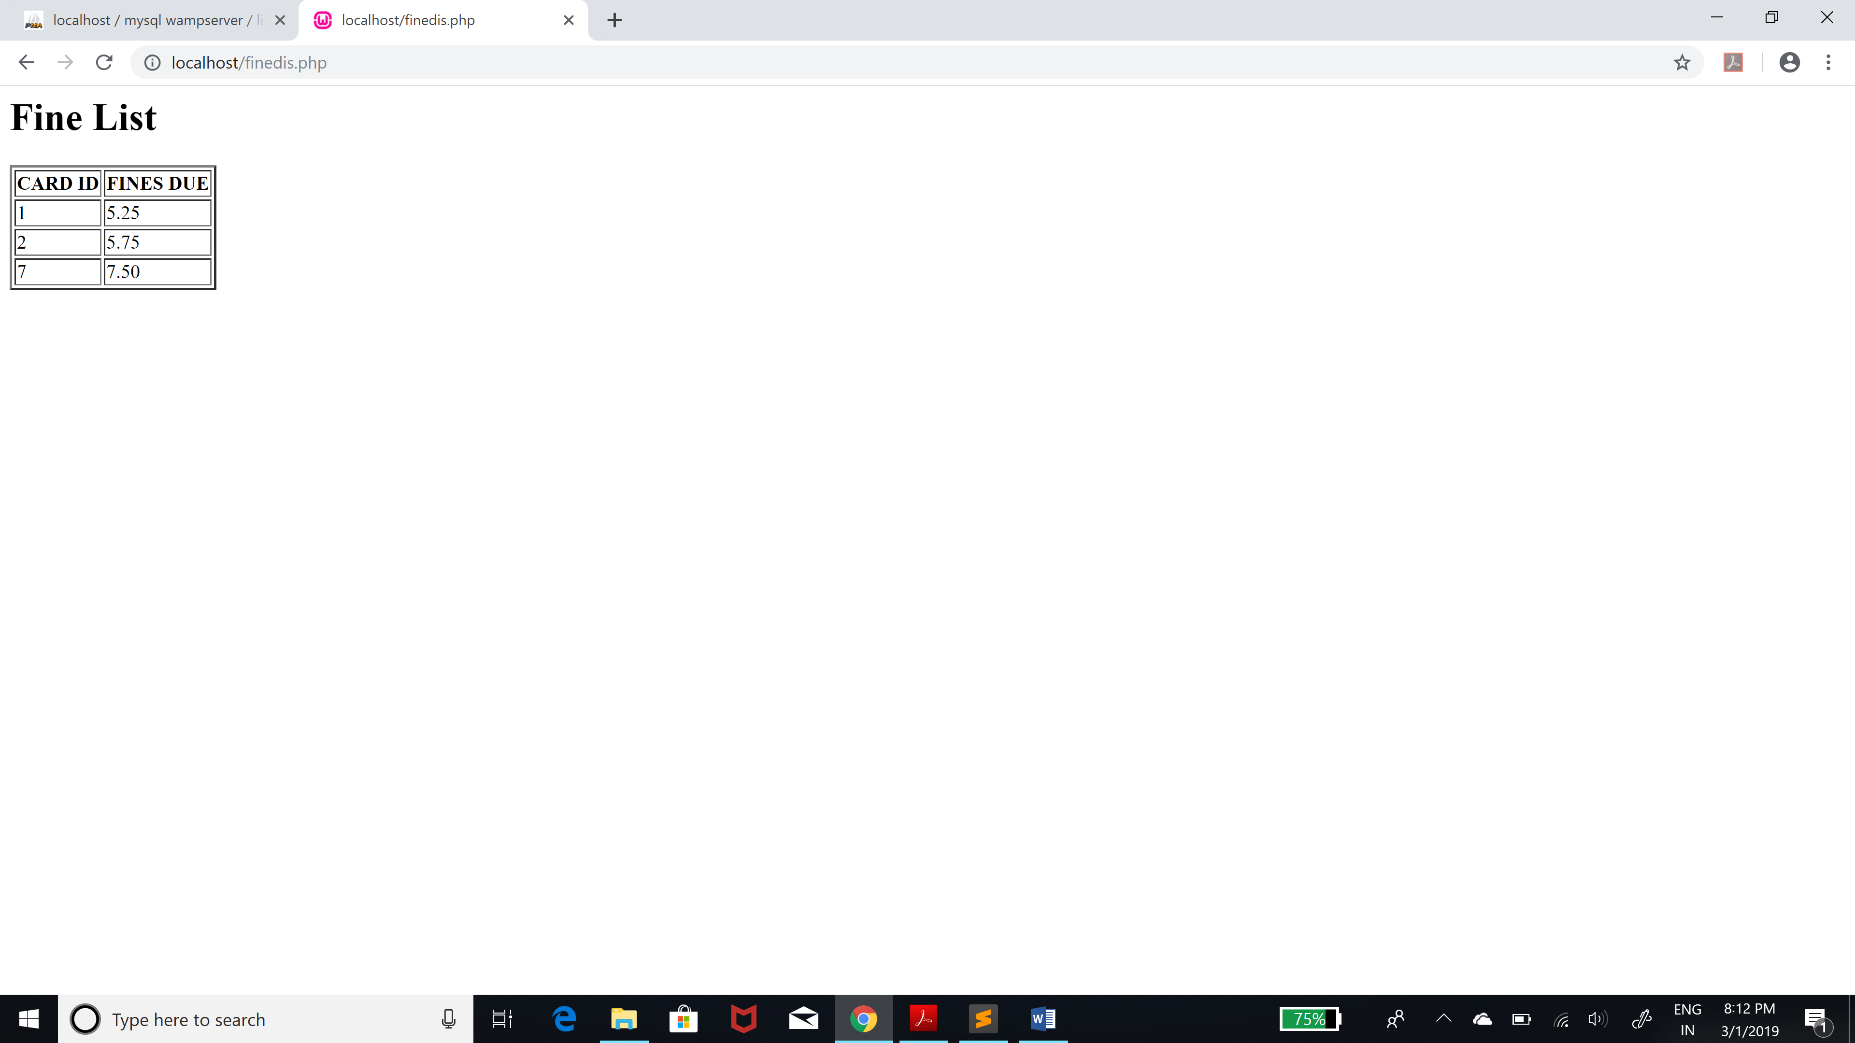

A new student can be registered and an unique card id will be given to him. However he must provide all the information during registration. If the student already has a card id he won’t receive a new one.

